Instructions on Filling out the Intake Form as a PDF or as a Word Doc.

Filling Out the Intake Form as a Word Document:
- Download the intake form as a Word Doc.
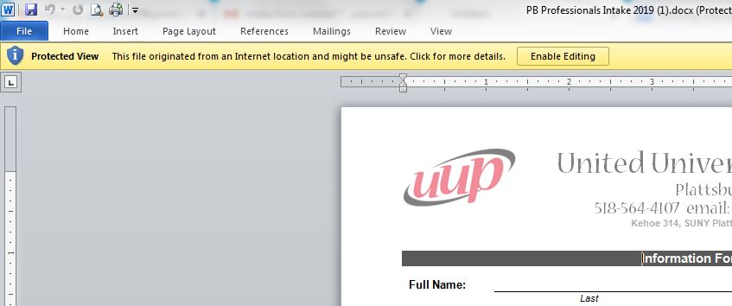
- Click Enable Editing in the popup bar at the top of the document, under the menu:

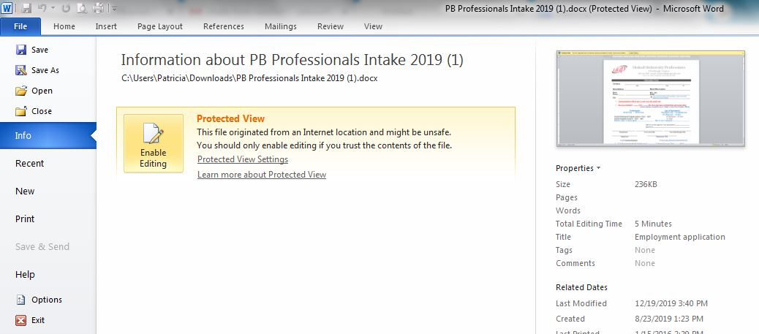
- Or you can enable editing by selecting File, then Info, then under Protected View:

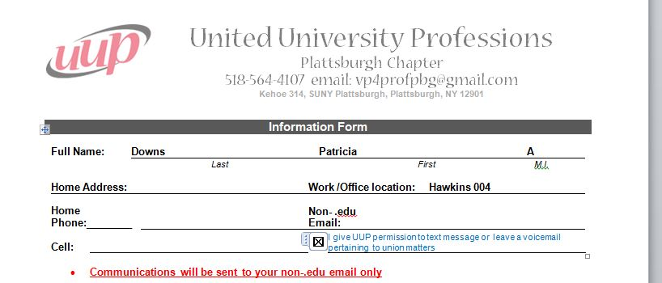
- After enabling editing, you can click directly into the document with your cursor and fill it out. You can type into the fields and click/mark checkboxes:

Filling Out the Intake Form as a PDF:
- Download the form as a pdf.
- If you have Adobe, open the pdf version in Acrobat Reader.
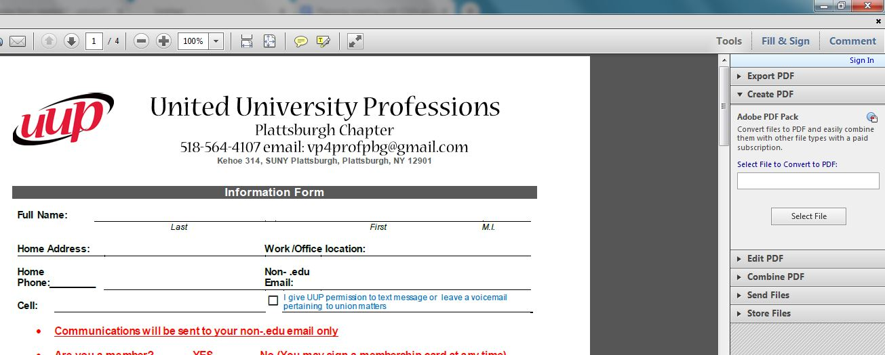
- Select "Fill and Sign" on the far right side of the top toolbar, above a right-hand sidebar:
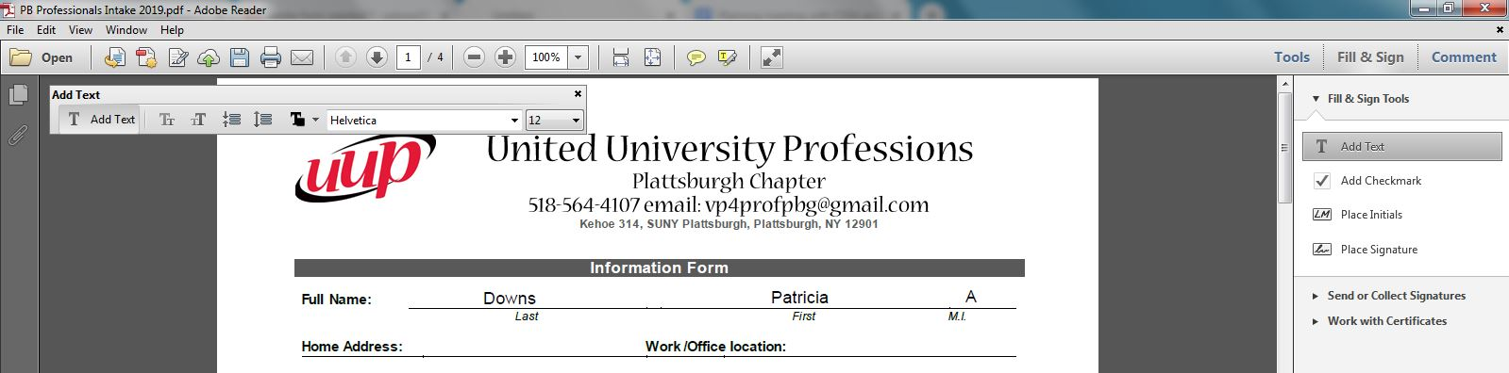
- In the Fill and Sign section, select Add Text. Then you can click your cursor on the lines/fields of the pdf and type your responses:

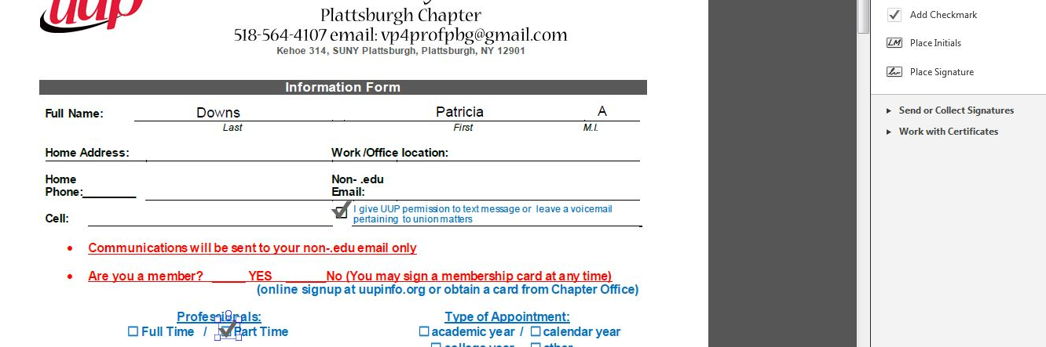
- Select the Add Checkmark option for filling in checkboxes:
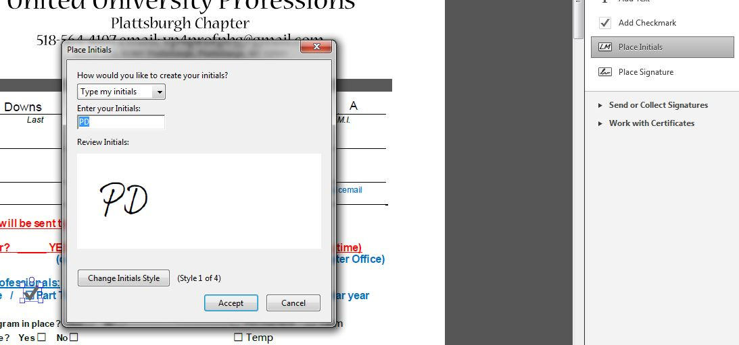
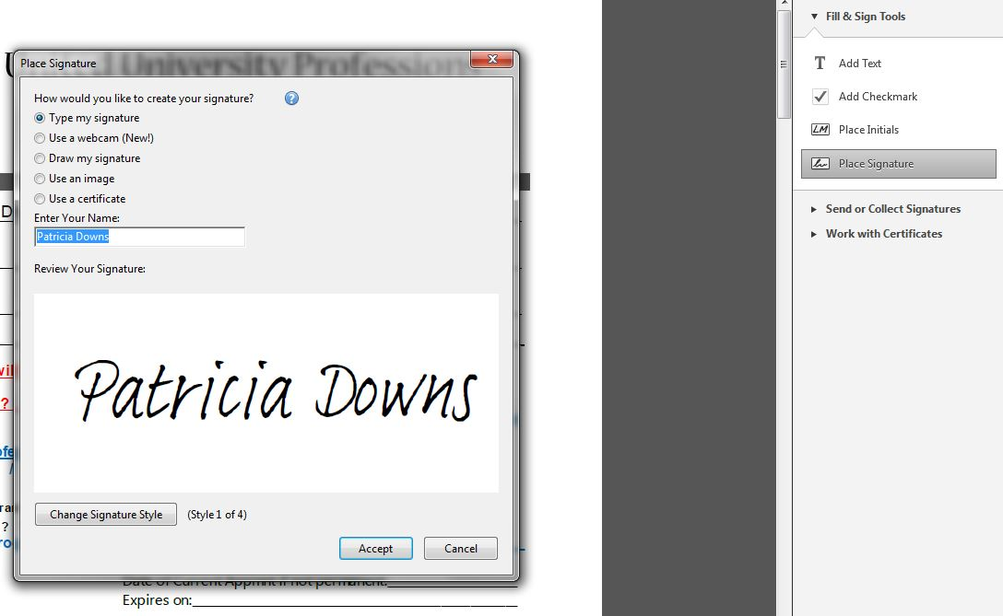
- Select Initial or Signature to type or place your initials or signature:

